- \Operation\Monitoring, carton labeling\Monitoring, carton labeling
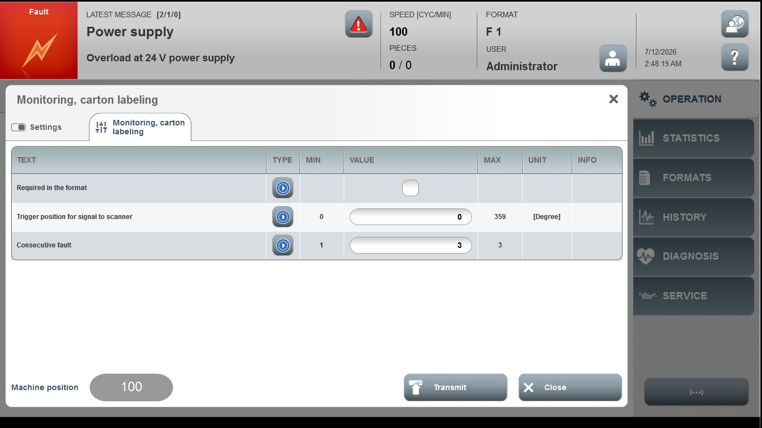

Acceptance criterion | Limits | Pass / Fail: Dev-No. | Date | Initials
Screen matches screenshot | N / A
Trigger position for the signal on the scanner | 0 … 359
Consecutive fault | 1 … 3

